EXPERIMENTS

NAME:BHARANI DHARAN S
REG NO:192424141
COURSE CODE:DSA0602 DATA HANDLING AND VISUALIZATION

SET 3 – PRODUCT SALES ANALYSIS

Product ID | Product Name | January Sales | February Sales | March Sales
1 | Product A | 2000 | 2200 | 2400
2 | Product B | 1500 | 1800 | 1600
3 | Product C | 1200 | 1400 | 1100

QUESTION 1
Create a grouped bar chart to visualize the sales of each product for the first quarter. Label the chart elements.

AIM
To create a grouped bar chart to visualize the January, February, and March sales of each product.

PROCEDURE
- Create the monthly product sales data.
- Store the sales of each product for January, February, and March.
- Arrange the data into a matrix.
- Use the barplot() function.
- Set beside = TRUE to create grouped bars.
- Add axis labels, title, and legend.

CODE

product <- c("Product A", "Product B", "Product C")

sales <- matrix(
c(2000, 2200, 2400,
1500, 1800, 1600,
1200, 1400, 1100),
nrow = 3,
byrow = TRUE
)

colnames(sales) <- c("January", "February", "March")
rownames(sales) <- product

barplot(
sales,
beside = TRUE,
names.arg = c("January", "February", "March"),
xlab = "Month",
ylab = "Sales",
main = "Monthly Product Sales",
legend.text = rownames(sales),
ylim = c(0, 2600)
)

OUTPUT

RESULT
Thus, the grouped bar chart was successfully created to visualize the first-quarter sales of each product.

QUESTION 2
Generate a stacked area chart to represent the overall sales trend for all products over the three months.

AIM
To create a stacked area chart showing the sales trend of all products over January, February, and March.

PROCEDURE
- Create the monthly sales data.
- Store the sales of each product.
- Calculate cumulative sales for stacking.
- Create the area chart using polygon().
- Add labels, title, and legend.

CODE
months <- c("January", "February", "March")

product_a <- c(2000, 2200, 2400)
product_b <- c(1500, 1800, 1600)
product_c <- c(1200, 1400, 1100)

total_ab <- product_a + product_b
total_abc <- product_a + product_b + product_c

x <- 1:3

plot(
x,
total_abc,
type = "n",
xaxt = "n",
xlab = "Month",
ylab = "Sales",
main = "Stacked Area Chart of Product Sales",
ylim = c(0, 6000)
)

axis(
1,
at = x,
labels = months
)

polygon(
c(x, rev(x)),
c(rep(0, 3), rev(product_a)),
border = "black"
)

polygon(
c(x, rev(x)),
c(product_a, rev(total_ab)),
border = "black"
)

polygon(
c(x, rev(x)),
c(total_ab, rev(total_abc)),
border = "black"
)

legend(
"topleft",
legend = c("Product A", "Product B", "Product C"),
fill = c("grey80", "grey60", "grey40")
)
OUTPUT

RESULT
Thus, the stacked area chart was successfully created to represent the overall sales trend of all products over the three months.

QUESTION 3
Build a table to show the monthly sales data for each product. Label the table elements.

AIM
To create a table displaying the monthly sales of each product.

PROCEDURE
- Create the product sales data.
- Store Product ID, Product Name, January, February, and March sales.
- Create a data frame.
- Display the data frame as a table.

CODE
product_id <- c(1, 2, 3)

product_name <- c(
"Product A",
"Product B",
"Product C"
)

january <- c(2000, 1500, 1200)

february <- c(2200, 1800, 1400)

march <- c(2400, 1600, 1100)

sales <- data.frame(
Product_ID = product_id,
Product_Name = product_name,
January_Sales = january,
February_Sales = february,
March_Sales = march
)

print(sales)

OUTPUT

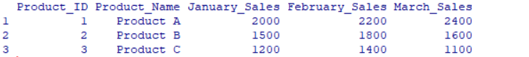

RESULT
Thus, a stacked area chart was successfully created to visualize the distribution of website user interactions.

QUESTION 4

Develop a Tableau dashboard combining the grouped bar chart, stacked area chart, and the table for interactive exploration of sales data.

AIM
To develop an interactive product sales dashboard using R Shiny containing a grouped bar chart, stacked area chart, and sales table.

PROCEDURE
- Install the shiny and ggplot2 packages.
- Create the monthly product sales dataset.
- Create a user interface with a product filter.
- Create a grouped bar chart.
- Create a stacked area chart.
- Create a sales table.
- Display all three outputs in the dashboard.
- Run the Shiny application.
- Use the product filter to interact with the data.

CODE
library(shiny)
library(ggplot2)

sales <- data.frame(
Product_ID = c(1, 2, 3),
Product_Name = c("Product A", "Product B", "Product C"),
January = c(2000, 1500, 1200),
February = c(2200, 1800, 1400),
March = c(2400, 1600, 1100)
)

long_data <- data.frame(
Product = rep(sales$Product_Name, each = 3),
Month = rep(c("January", "February", "March"), 3),
Sales = c(
sales$January,
sales$February,
sales$March
)
)

ui <- fluidPage(
titlePanel("Product Sales Analysis Dashboard"),

sidebarLayout(
sidebarPanel(
selectInput(
"product",
"Select Product:",
choices = c("All", sales$Product_Name),
selected = "All"
)
),

mainPanel(
plotOutput("barChart"),
plotOutput("areaChart"),
tableOutput("salesTable")
)
)
)

server <- function(input, output) {

filtered_data <- reactive({
if (input$product == "All") {
long_data
} else {
long_data[long_data$Product == input$product, ]
}
})

output$barChart <- renderPlot({
ggplot(
filtered_data(),
aes(x = Month, y = Sales, fill = Product)
) +
geom_bar(
stat = "identity",
position = "dodge"
) +
labs(
title = "Grouped Bar Chart of Product Sales",
x = "Month",
y = "Sales"
)
})

output$areaChart <- renderPlot({
ggplot(
filtered_data(),
aes(x = Month, y = Sales, fill = Product, group = Product)
) +
geom_area(position = "stack") +
labs(
title = "Stacked Area Chart of Product Sales",
x = "Month",
y = "Sales"
)
})

output$salesTable <- renderTable({
if (input$product == "All") {
sales
} else {
sales[sales$Product_Name == input$product, ]
}
})
}

shinyApp(ui = ui, server = server)

OUTPUT
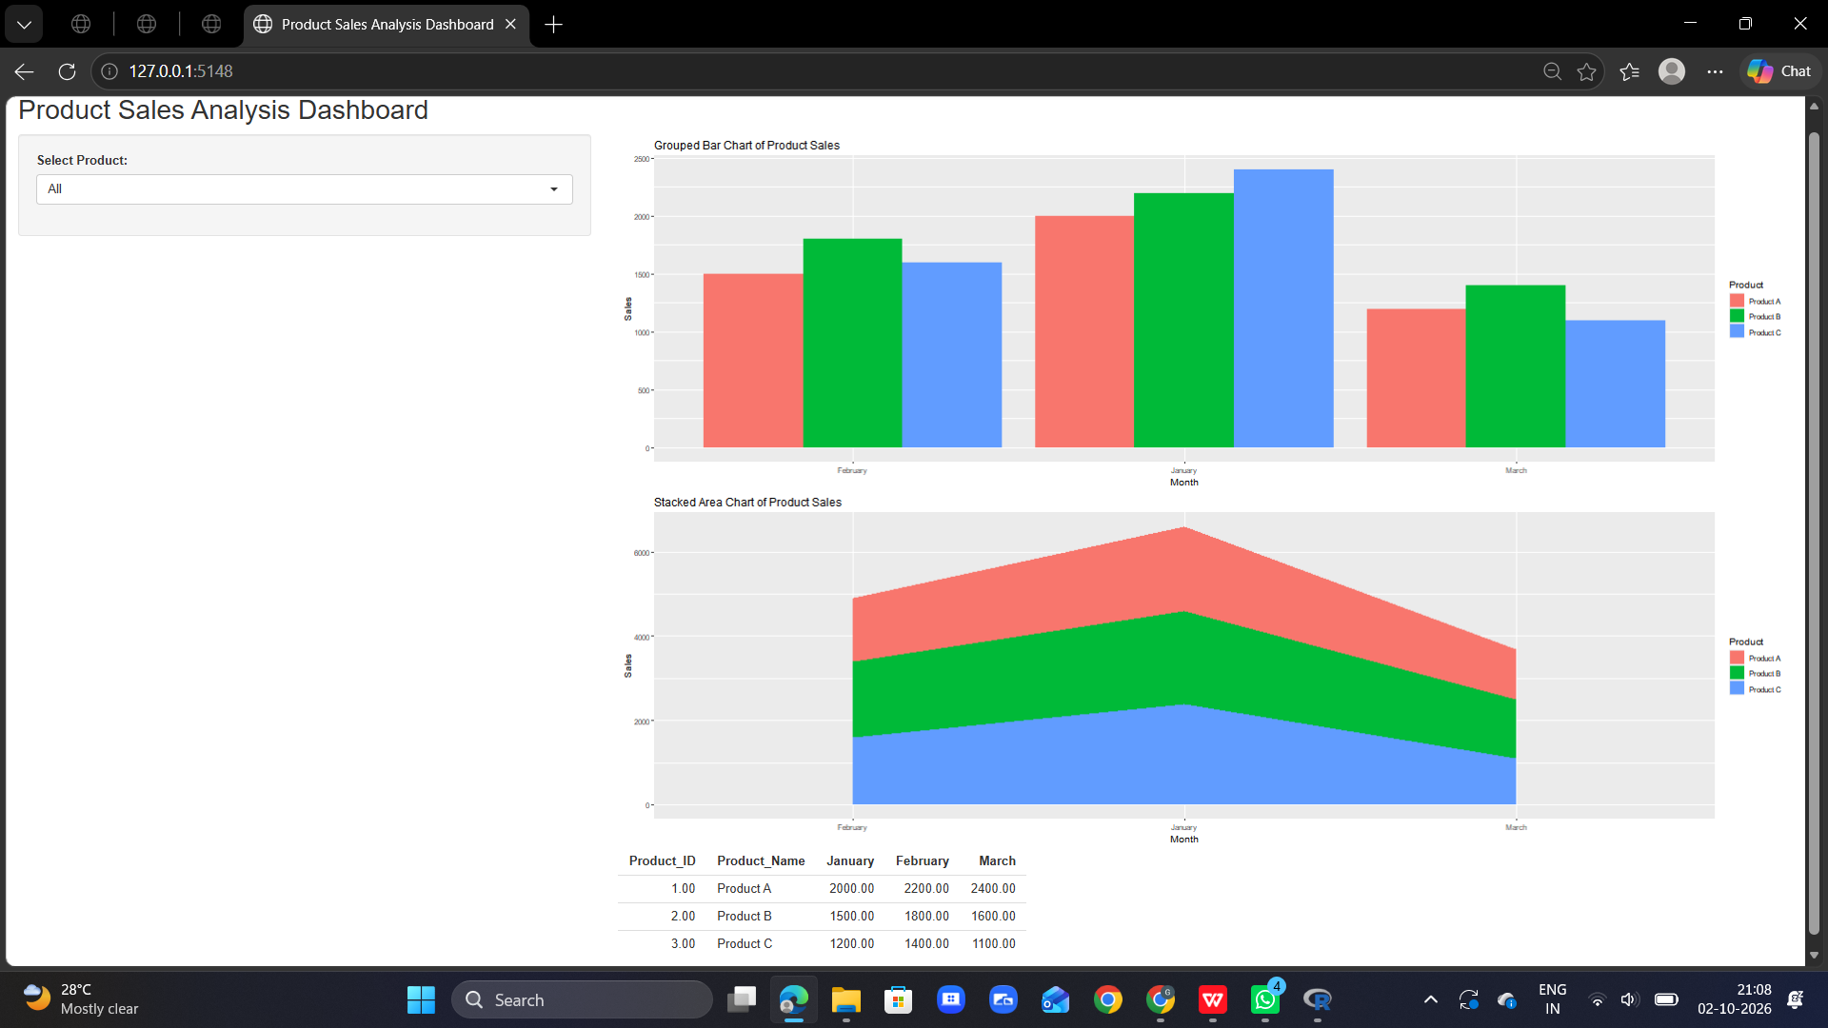

RESULT
Thus, an interactive Product Sales Analysis Dashboard was successfully developed using R Shiny, containing a grouped bar chart, stacked area chart, and monthly sales table.

